INVESTMENT STRATEGIES ANALYSIS

Written by: Asmaa Abbassi, Marc de Froidefond, Thomas Monnier, Benedek Király

1. **Return**

For analyzing returns and portfolio performance we decided to choose a dummy date as a starting point, 1st of July, 2020.

* 1 month analysis

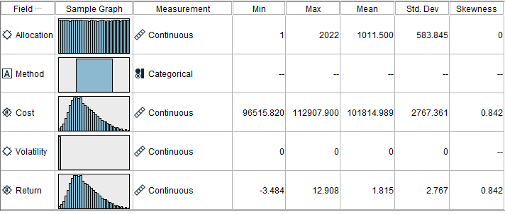

* 3 months analysis

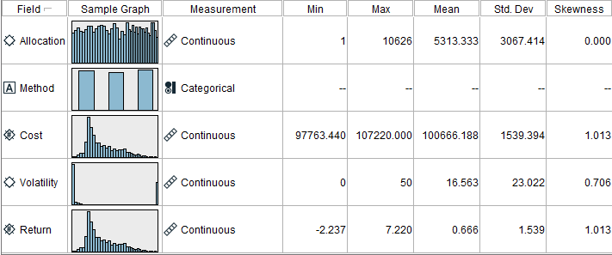

Comparing our two output files, average returns seem to be significantly lower on 3 months investment allocations.

Due to the high memory demand of the application and time constraint. we could not extract more, than 3 months of data (3 months took more than 40 minutes), hence we will use our 3 months analysis’ data for further tasks.

1. **Return vs. Risk**

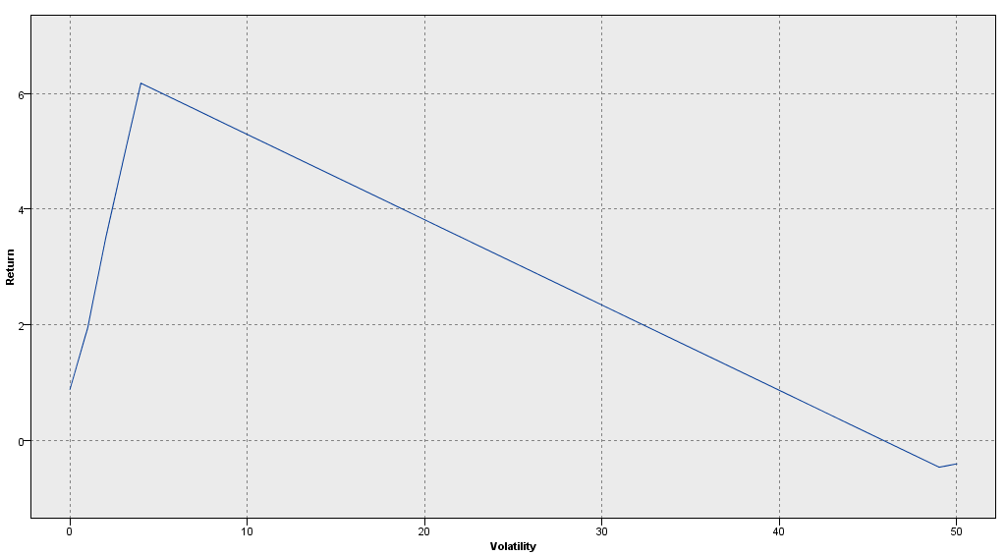The graph shows, that the linearity between risk and return is only true up to a certain point, from where more risk won’t naturally attract more return in the investment.

1. **Financial advisoring**